Database Design Coursework Template

Abstract

The database stores the details of the stock and staff in every warehouse for an e-commerce store. It also stores the customers and sellers that have accounts on the website, detailing the items they have bought. This database will not only keep a record of customers and sellers; it will also provide insightful information of all entities within the database, such as the types of stock people of a certain age buy. It keeps invoices of the stock items customers buy, too.

Example queries

- Display all Customer IDs who have their birthdays today
- Display all Customer IDs that are also investors
- Display the card number of the user who owns Stock ID 3588 of ItemID 1266
- Display the category that people aged 50-60 are buying the most stock from
- Display the Warehouse ID that has the least number stock

Entity Relationship Model

Conceptual Model

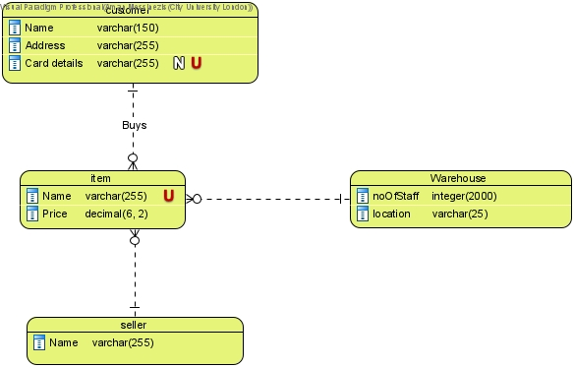

Logical Model
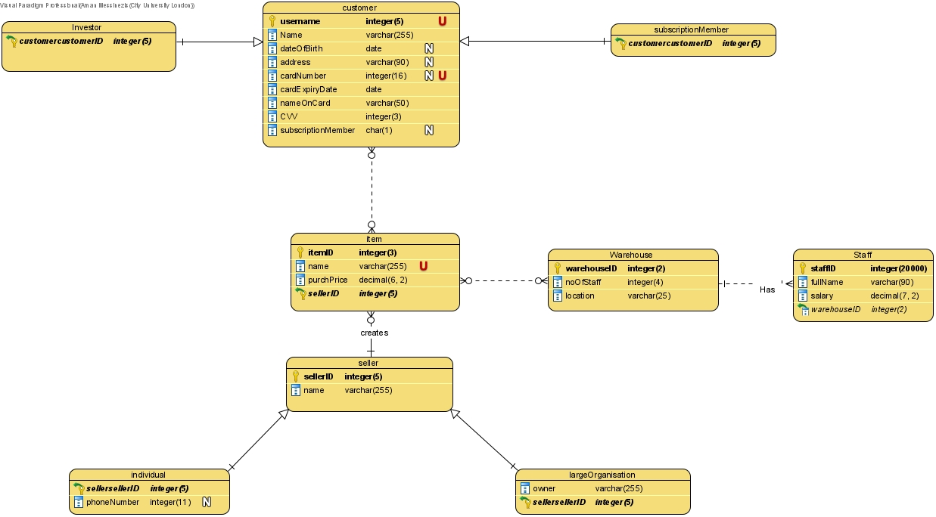

Physical Model

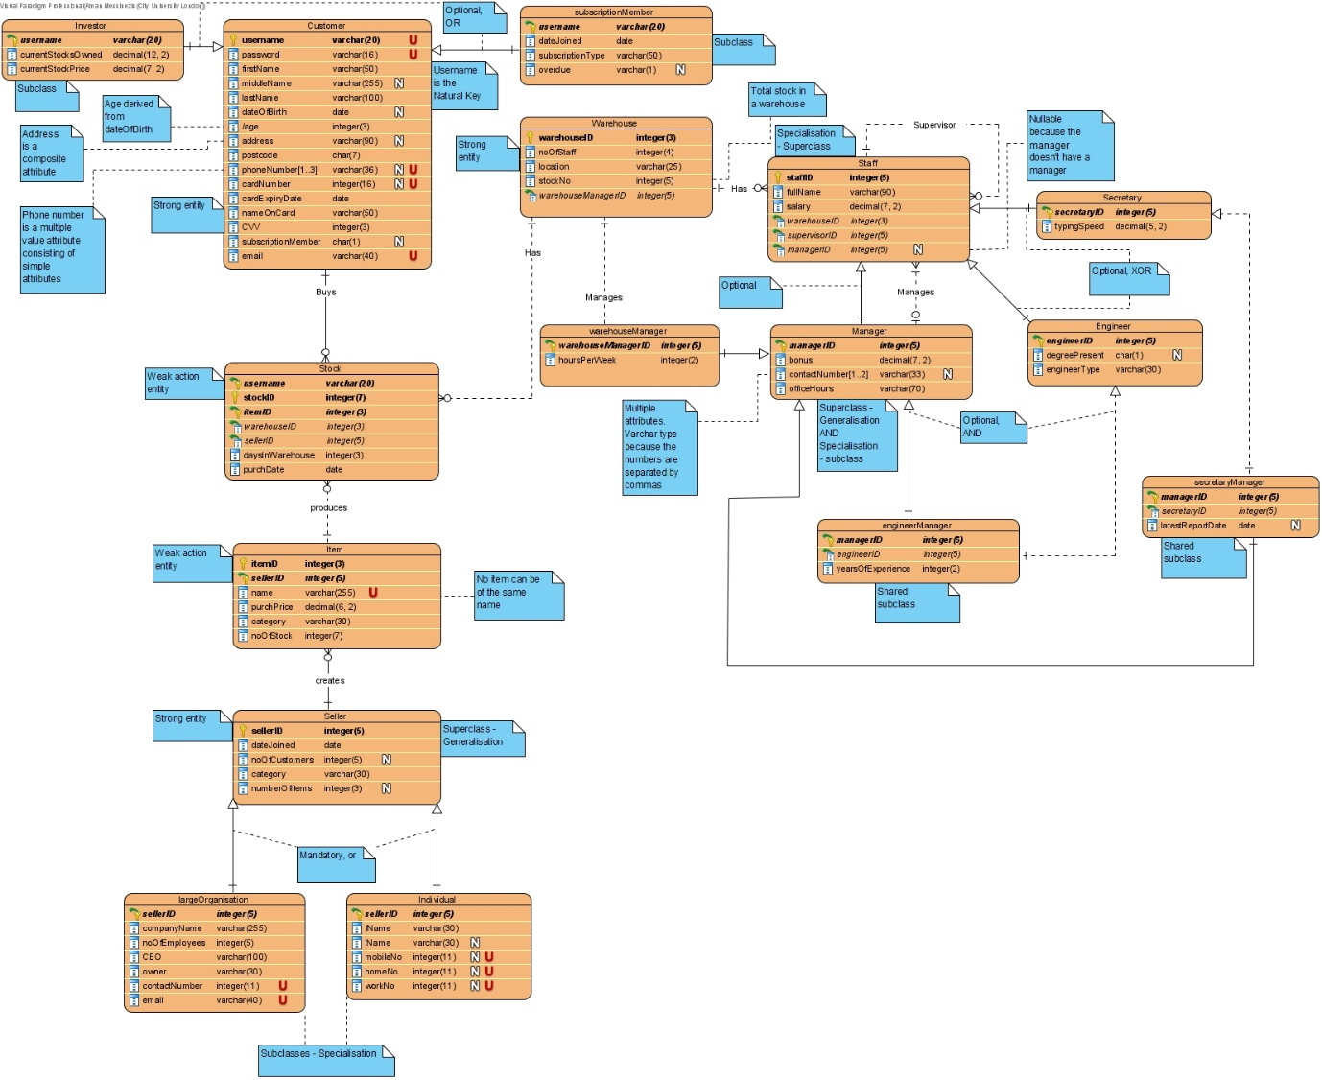

Relational Model Tables

“/” represents a derived attribute

Relational table specification
Table name: Customer
Attributes
firstName
middleName
lastName
dateOfBirth
/age
addressFirstLine
addressSecondLine
addressThirdLine
postcode
mobileNumber
homeNumber
workNumber
cardNumber
cardExpiryDate
nameOnCard
CVV
subscriptionMember
email
password
PRIMARY KEY (username)

Relational table specification
Table name: Investor
Attributes
Customer attributes
currentStocksOwned
currentStockPrice
PRIMARY KEY (username)
FOREIGN KEY (username) REFERENCES Customer (username)

Relational table specification
Table name: subscriptionMember
Attributes
Customer attributes
dateJoined
subscriptionType
overdue
PRIMARY KEY (username)
FOREIGN KEY (username) REFERENCES Customer (username)

Relational table specification
Table name: Seller
Attributes
dateJoined
noOfCustomers
category
numberOfItems
PRIMARY KEY (sellerID)

Relational table specification
Table name: largeOrganisation
Attributes
Seller attributes
companyName
noOfEmployees
CEO
owner
contactNumber
email
PRIMARY KEY (sellerID)
FOREIGN KEY (sellerID) REFERENCES Seller (sellerID)

Relational table specification
Table name: Individual
Attributes
Seller attributes
fName
lName
mobileNo
homeNo
workNo
PRIMARY KEY (sellerID)
FOREIGN KEY (sellerID) REFERENCES Seller (sellerID)

Relational table specification
Table name: Item
Attributes
name
purchPrice
category
noOfStock
PRIMARY KEY (itemID, sellerID)
FOREIGN KEY (sellerID) REFERENCES Seller (sellerID)

Relational table specification
Table name: Warehouse and Warehouse Manager (combined entity)
Attributes
Manager attributes
noOfStaff
location
stockNo
hoursPerWeek
PRIMARY KEY (warehouseID)
FOREIGN KEY (warehouseManagerID) REFERENCES Manager (managerID)

Relational table specification
Table name: Staff
Attributes
fullName
salary
PRIMARY KEY (staffID)
FOREIGN KEY (warehouseID) REFERENCES Warehouse (warehouseID)
FOREIGN KEY (supervisorID) REFERENCES Staff (staffID)
FOREIGN KEY (managerID) REFERENCES Manager (managerID)

Relational table specification
Table name: Secretary
Attributes
Staff attributes
typingSpeed
PRIMARY KEY (secretaryID)
FOREIGN KEY (secretaryID) REFERENCES Staff (staffID)

Relational table specification
Table name: Engineer
Attributes
Staff attributes
degreePresent
engineerType
PRIMARY KEY (engineerID)
FOREIGN KEY (engineerID) REFERENCES Staff (staffID)

Relational table specification
Table name: Manager
Attributes
Staff attributes
bonus
workNumber
mobileNumber
PRIMARY KEY (managerID)
FOREIGN KEY (managerID) REFERENCES Staff (staffID)

Relational table specification
Table name: engineerManager
Attributes
Manager attributes AND Engineer attributes
yearsOfExperience
PRIMARY KEY (managerID)
FOREIGN KEY (managerID) REFERENCES Manager (managerID)
FOREIGN KEY (engineerID) REFERENCES Engineer (engineerID)

Relational table specification
Table name: secretaryManager
Attributes
Manager attributes AND Secretary attributes
latestReportDate
PRIMARY KEY (managerID)
FOREIGN KEY (managerID) REFERENCES Manager (managerID)
FOREIGN KEY (secretaryID) REFERENCES Engineer (secretaryID)

Relational table specification
Table name: Stock
Attributes
daysInWarehouse
purchDate
PRIMARY KEY (username, itemID)
FOREIGN KEY (username) REFERENCES Customer (username)
FOREIGN KEY (itemID) REFERENCES Item (itemID)
FOREIGN KEY (warehouseID) REFERENCES Warehouse (warehouseID)
FOREIGN KEY (sellerID) REFERENCES Seller (sellerID)

